Minutes of the Regular meeting of the Township Committee of the Township of Commercial, held on December 15, 2022, at 6:00 P.M., at the Township Hall at 1768 Main Street. Port Norris, NJ

Those Present:
Mike Vizzard Mayor
Joseph Klaudi Committeeman
Thomas Seeley Solicitor
Heather Miller Township Clerk
Clint Miller Public Works Supervisor
Nick DiCosmo Engineer

Those Absent:
Fletcher Jamison Deputy Mayor

Mayor Vizzard presided and called the meeting to order with the announcement that the meeting had been advertised, it was being electronically recorded and being held in compliance with the Open Public Meeting Act.

Mayor Vizzard asked the attendees to join him in the flag salute and the Lord’s Prayer.

No State Police present to give a report. Mayor Vizzard asked for the Engineers report.

Nick DiCosmo –

Miller Ave. Bridge – The DEP is reviewing our modeling of the Miller Ave. bridge. I did hear from them; they are requesting some additional information on the details of the model. I did get that to them and now I’m waiting to hear back but I know they are reviewing it so once we get the green light from them, we will complete the permitting process and get that wrapped up.

Reconstruction of Brown Street – Has been completed and payment no 1. Should be on the agenda for approval. They are a few punch list items. I am working with the contractor to get all of them addressed.

Yock Wock & High Streets – Are still in design

Mill & Overlay of Main Street – He heard from Doug at the County; the County is going to start drafting up the interlocal agreement. We will resume getting all that finalized hopefully in January. This and Yock Wock will be Spring and Summer construction.

2023 Local Recreation Grant – We are going to submit the application for improvements at the Mauricetown Riverfront Park.

Gas Co repairs in Laurel Lake – This is currently on going. This is a mill and overlay on Doris Dr. and various side streets. This is slated to be completed before Christmas.

2023 Local Freight Impact Fund for Strawberry Ave. – Grant application was submitted on Tuesday (13th).

Nick DiCosmo – I spoke to the DOT after the Monday night meeting about the 2023 state aid application because I had questions but yes, we did get the funding for the North Avenue pedestrian improvements however we did not receive the funding for Milbourne Drive and Dennis Lane. I, as well as everyone else in my office, had the impression that we prioritize our applications for a reason. Our priority 1 was Milbourne Drive and Dennis Lane because I believe we are on the same page as a township and the committee that roads and drainage are our first priority. So as a priority 2, we would do the North Avenue pedestrian path which is a good project. But we were all under the impression that priority 1 would get the funding and if there is funding still available then priority 2 would get funded. After speaking to the DOT, apparently, they don’t care about our priority. They rated both applications and to them, the pedestrian application just simply rated higher, and it did not matter that we prioritized Milbourne Drive as our priority and that’s the answer I received. Lesson learned; we won’t submit two applications again. Having said that, I think the North Avenue project is a good project and I think I’m going to go back to the county for another interlocal agreement because this is a long stretch of North Ave which is a County Road. Maybe we can add to it. When Nick spoke to the DOT, the contact mentioned discretionary aid. This may be an option for funding if we can show it is more of an emergency need.

Mayor Vizzard – As far as the parks, and we are going to focus our priority on getting the Mauricetown Park fixed but can we apply for additional? Can we apply for Mauricetown and the park in Laurel Lake at the same time?

Nick DiCosmo – I believe that we can, but I don’t know if it will be a similar scenario so I’m going to have to get in touch with someone there. We may need to focus on Mauricetown to help our case.

Mayor Vizzard – I’m just concerned they aren’t going to consider Mauricetown a Park. I don’t want to end up with nothing.

Committeeman Klaudi- What was the price tag for the Mauricetown Park?

Nick DiCosmo- I believe it was something like $700,000 for a new bulkhead, parking lot and some sidewalks.

Mayor Vizzard – What does the average park go for as far as swing sets? Do you think $100,000 would cover an average park?

Nick DiCosmo- I would think so. I guess it just depends on what we are doing.

Mayor Vizzard moved on to correspondence.

Correspondence from Remington & Vernick Engineers for grant application proposal for application of the 2023 Local Recreation Improvement Grant Program. Applications due January 20, 2023. Discussion of repairs to the Mauricetown Park which is what we just discussed.

Correspondence from Eduard Gilbert Renart. He has rescinded his request for a lien assignment previously approved for 1061 Charles Place as a result of findings through a title search. Mr. Renart is now requesting a lien assignment for 501 Opal Rd. Current lien value is $3,253.43.

Mayor Vizzard asked for a motion to approve Mr. Renart’s request. A motion was made by Committeeman Klaudi and was seconded by Mayor Vizzard. Roll call vote. The majority vote was to approve.

Correspondence from Remington & Vernick Engineers requesting Payment Certificate #1 to be considered for Reconstruction of Brown Street in the amount of $330,459.63 to Asphalt Paving Systems.

Resolutions –

RESOLUTION 2022-110
Awarding a One Year Contract to Shore Animal Control for Animal Control Services in An Amount Of $18,000 For 2023

WHEREAS, the Township of Commercial received a proposal for Animal Control
Officer Services and was reviewed by the Township Committee and Solicitor.

BE IT RESOLVED by the Township Committee of the Township of
Commercial that a contract be awarded to Shore Animal Control for Animal Control Services, PO Box 597 Tuckahoe, NJ 08250 for a period of one year in the amount of $18,000 for 2023 with the option to extend for 2024 at $1,600 per month.

As required by NJSA 40A:4-57 and NJAC 5:30-14.5, I, Pamela Humphries, Chief Financial Officer of the Township of Commercial, have ascertained that there will be made available sufficient uncommitted appropriations in the 2023 Township Municipal Budget to award a contract to:
Shore Animal Control for Animal Control Services for the year 2023 in an amount not to exceed $18,000. Funds for certification are therefore being made available and certified against the following appropriations Account Numbers:
Account Number Amount
3-01-27-340-020 $18,000.00

RESOLUTION 2022-111
Approving Proposal of Remington & Vernick Engineers
For Preparation of Application for Fiscal Year 2023 Local Recreation Improvement Grant (LRIG) Program

BE IT RESOLVED by the Township Committee of the Township of Commercial that
Proposal of Remington & Vernick Engineers for the preparation of application for Fiscal Year 2023 Local Recreation Improvements Grant (LRIG) Program for Mauricetown Riverfront Park restorations in the amount of $3,400 is approved by the chief financial officer with funding coming from the following accounts:

Line Item:
Engineering O/E Balance $5,173.00
2-01-20-165-028 Certify $3,400.00
Balance $1,773.00

Resolution 2022-112
Authorizing Assignment

WHEREAS, NJSA 54:5-113 authorizes assignment by a municipality of tax sale certificate for the full amount of the certificate, including all subsequent municipal taxes and other municipal charges; and

WHEREAS, Mobile House Investment, LLC has presented an offer to purchase, by assignment, Certificate # 22-00030, which was issued to the Township of Commercial at a tax sale held January 12, 2022 on Block 53, Lot 7210, known as 100 Sandalwood Rd. Millville, NJ and assessed to Patrick Twilley & Mary Fitzsimons in the amount of $2,229.98. Being the full amount of the certificate, including all subsequent municipal taxes and other municipal charges.

NOW, THEREFORE, BE IT RESOLVED, that the Township of Commercial hereby authorize assignment of the above-referenced Certificate of Sale.

BE IT FURTHER RESOLVED that a copy of this resolution be forwarded to the Tax Collector.

COMMERCIAL TOWNSHIP
RESOLUTION 2022-113

Approving 2023 Annual Compensation for the Commissioners of the Commercial Township Fire District No 1.

WHEREAS N.J.S.A. 40A:14-88 requires the municipal governing body to review and approve such compensation before the fire district can submit its annual budget to the voters, or, in the case of fire districts whose Board of Commissioners elections coincides with the November General Election, before the district can adopt its annual budget.

WHEREAS, the fire district must seek annual approval of elected commissioner compensation from the municipal governing body regardless of whether the Board is modifying the amount of compensation.

WHEREAS, the Board of Fire Commissioners of the Commercial Township Fire District No 1 have proposed annual compensation for various members of their Board of Fire Commissioners for 2023 as follows:

Chairman: $500
Vice Chairman $500
Treasurer: $2,000
Secretary: $2,000
Commissioner: $500

NOW, THEREFORE, BE IT RESOLVED by the Mayor and Committee of the Township of Commercial, County of Cumberland and State of New Jersey, that the Committee of the Township of Commercial hereby approve the 2023 annual compensation of the Board of Fire Commissioners of the Township of Commercial Fire District No. 1. to be paid from the Fire District No.1, 2023 annual budget

Resolution 2022-114
Awarding contract to Riverside Construction Materials, Inc. for Rock Salt at $81.50 per ton for Public Works.

WHEREAS, Commercial Township is a member of Cumberland County Cooperative System Identifier #181-CCCCPS; and

WHEREAS, Cumberland County Purchasing Office solicited bids for the purchase of
Rock Salt and have awarded a contract to Riverside Construction Materials, Inc., for Rock Salt at $8150 per ton; therefore

BE IT RESOLVED by the Township Committee of the Township of Commercial that
a contract be awarded to Riverside Construction Materials, Inc., for Rock Salt at cost of $81.50 per ton for Commercial Township Public Works Department, period of December 1, 2022, through November 30, 2023 as a member of Cumberland County Cooperative System #181-CCCCPS.
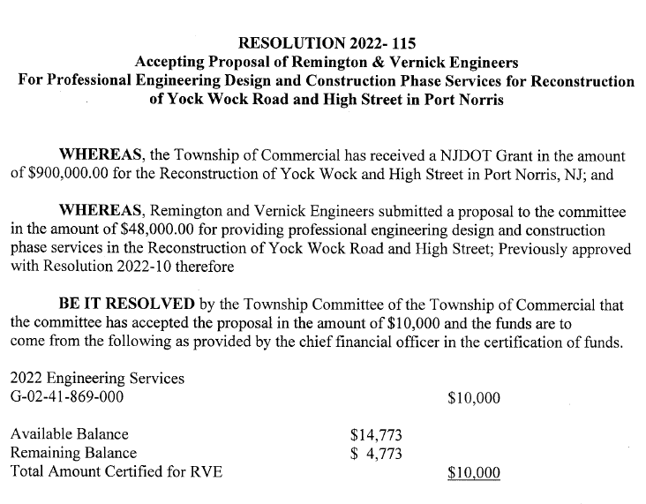

RESOLUTION 2022-116
BUDGET LINE-ITEM TRANSFERS

BE IT RESOLVED, by the Township Committee of the Township of Commercial that the following budgetary transfers be made to avoid over-expenditures in the 2022 Municipal Budget as requested by the Chief Financial Officer.

Line-Item Amount
From:
OEM O/E 159
Tax Title Lien Coordinator 4,000
Land Use O/E 100
Library S/W PT 200
Data Processing 5,000
Group Health Insurance 2,000

Total 11,459

Line-Item Amount
To:
OEM S/W 159
Legal Services 4,000
Land Use S/W 100
Senior Center S/W PT 200
Street Lights 7,000

Total 11,459

RESOLUTION 2022-117

Approving Bingo and Raffle License Applications Of The Laurel Lake
Volunteer Fire & Rescue Inc., For Year 2023

BE IT RESOLVED by the Township Committee of the Township of Commercial that

the application of the Laurel Lake Volunteer Fire and Rescue, Inc. organization to conduct Bingo

Games and Raffles during the year 2023 is approved to allow its members to purchase

additional fire and rescue equipment from the proceeds while providing the local residents

with entertainment.

BE IT FURTHER RESOLVED that all applications shall be forwarded to the State of

New Jersey Legalized Games of Chance Control Commission for final approval prior to license

being issued.

Commercial Township
Resolution 2022-118
A RESOLUTION ADOPTING TECHNOLOGY RISK MANAGEMENT STANDARDS IN COMPLIANCE WITH THE NEW JERSEY MUNICIPAL EXCESS LIABILITY JOINT INSURANCE FUND’S CYBER RISK MANAGEMENT PLAN’S TIER THREE REQUIREMENTS
Whereas, the Township of Commercial is a member of the Atlantic County JIF which secures insurance protection through the New Jersey Municipal Excess Liability Joint Insurance Fund (NJ MEL); and

Whereas, through its membership in the Atlantic County JIF, the Township of Commercial enjoys cyber liability insurance coverage to protect the Township of Commercial from the potential devastating costs associated with a cyber related claim; and

Whereas, in an attempt to prevent as many cyber related claims as possible, the NJ MEL developed and released to its members the NJ MEL Cyber Risk Management Plan; and

Whereas, the NJ MEL Cyber Risk Management Plan outlines a set of best practices and standards broken out into Tier 1, Tier 2, and Tier 3 standards that if adopted and followed will reduce many of the risks associated with the use of technology by the Township of Commercial; and

Whereas, in addition to the reduction of potential claims, implementing the following best practices and standards will enable the Township of Commercial to claim a reimbursement of a paid insurance deductible in the event the member files a claim against Township of Commercial’s cyber insurance policy, administered through the Atlantic County JIF and the Municipal Excess Liability Joint Insurance Fund;

Now Therefore Be It Resolved that the Township of Commercial does hereby adopt the following best practices and standards, a copy of which is attached hereto and incorporated herein by reference, in accordance with Tier 3 of the NJ MEL Cyber Risk Management Plan;
And, Be It Further Resolved, that a copy of this resolution along with all required checklists and correspondence be provided to the NJ MEL Underwriter for their consideration and approval.

RESOLUTION 2022-119

Approving Five Year Sand Mining Permitting License For
Covia Solutions, Inc. For Block 199, Lot 10, Block 200, Lots
1,17,18, Known as Phase 3A, Mining Site

BE IT RESOLVED by the Township Committee of the Township of Commercial that a five year sandmining permitting license be issued to Covia Solutions, Inc., P.O. Box 145 Millville, NJ 08332 for a conditional use together with site plan approval for mining/extraction of sand respecting premises as Block 199, Lot 10, Block 200, Lots 1, 17, & 18, known as Covia Solutions Inc. Phase 3A Mining Site as shown on the current tax map of the Township of Commercial and by recommendation of the Commercial Township Land Use Board; and

BE IT FURTHER RESOLVED that all requirements and stipulations as mandated by the Commercial Township Land Use Board’s Resolution 2022-06 be adhered to for the duration of the sandmining permitting license for Phase 3A,
Block 199, Lot 10, Block 200, Lots 1, 17, & 18; and

BE IT FURTHER RESOLVED that the expiration date of this five-year sandmining permitting license for Block 199, Lot 10, Block 200, Lots 1, 17, & 18 will be December 31, 2027, which runs with the current expiration date of December 31, 2022, in accordance with legislative Amendment of January 18, 2010 of the Permit Extension Act of 2008.

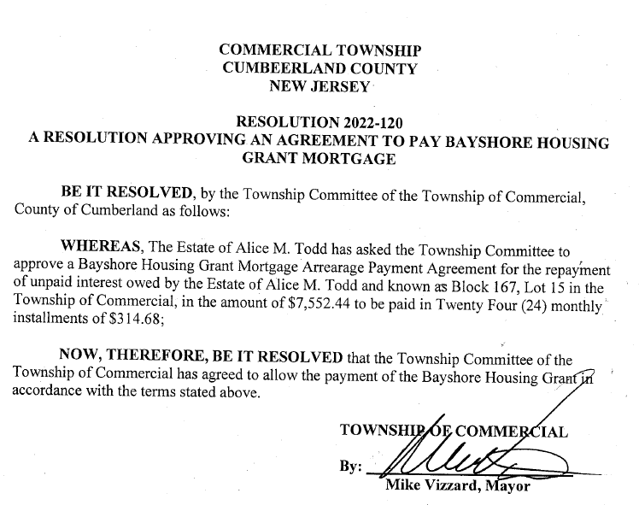

CERTIFICATION

I, Heather Miller, Clerk of the Township of Commercial hereby certify that the foregoing is a true and accurate copy of a resolutions unanimously adopted by the committee at their regular meeting held on December 15, 2022, at 6:00 P.M., at the Township Hall, 1768 Main Street, Port Norris, NJ

_________________________________________
Heather Miller, Township Clerk

Mayor Vizzard asked for a motion to approve resolutions 2022-110 through 2022-120

A motion was made by Committeeman Klaudi and was seconded by Mayor Vizzard, roll call vote, all were in favor.

Mayor Vizzard – Ordinance 2022-609 was introduced at the January 7, 2022, meeting, for use of funds for the Municipal Building to undergo renovations. At the February 2022 meeting, the Committee decided to table adoption of the ordinance to reallocate the funding for repairs at the Mauricetown Park. Later it was determined that the funding could not be used for the park repairs. Ordinance is on the agenda for second reading and adoption if the Committee decides to move forward with the building repairs.

Mayor Vizzard- We have two ordinances for second reading and adoption

Ordinance 2022-609
An Ordinance of the Township of Commercial, County of Cumberland, New Jersey, Providing for the use of funds for the Township Municipal Building to undergo renovations for Covid Mitigation and general upgrade to be fully funded from:

- 2021 American Rescue Plan Grant Reserve
- Capital Improvement Fund

BE IT ORDAINED, by the Township Committee of the Township of Commercial, County of Cumberland, New Jersey as follows:

Section 1: Funding for the Township Municipal Building to undergo renovations for Covid Mitigation and general upgrade.

Section 2: The total amount estimated of $118,000 is hereby appropriated as follows:

Capital Improvement Fund $76,000.00
2021 American Rescue Plan grant reserve $42,000.00

Section 3: This Ordinance shall take effect upon publication of notice of final adoption as provided by law on or about January 5, 2023

Mayor Vizzard asked for a motion to open discussion to the public for Ordinance 2022-609. Committeeman Klaudi made the motion and was seconded by Mayor Vizzard.

Mr. D’Ambrosio – What building repairs are being made?

Mayor Vizzard - We want to put electronic locks on the doors, We are going to re-locate these offices. We would like to put the Clerk’s office in the old court office and the tax office where the construction office is. We want to cut a window in the construction office to the lobby. What we want is if you come into this back lobby, you can access the Clerk’s office and the Tax Office. If you come in the front door, you will access the construction and zoning office. It will be a better handicap accessibility for the Clerk and Tax office.

Mayor Vizzard asked for a motion to close to the public. Committeeman Klaudi made the motion to close and was seconded by Mayor Vizzard.

Mayor Vizzard asked for a motion to adopt Ordinance 2022-609. A motion was made by Committeeman Klaudi and seconded by Mayor Vizzard. Roll call vote, all were in favor.

Mayor Vizzard- we have Ordinance 2022-613

Ordinance 2022-613
An Ordinance of the Township of Commercial, County of Cumberland, New Jersey, providing for the use of 2022 Budgeted Matching Funds for the 2021 NJDOT Freight Impact Fund for the replacement of the Miller Avenue bridge now available in the 2022 Municipal Budget

BE IT ORDAINED, by the Township Committee of the Township of Commercial, County of Cumberland, New Jersey as follows:

Section 1: Supplemental Matching Funds for 2021 NJDOT Freight Impact Grant for the Replacement of the Miller Avenue Bridge.

Section 2: The total amount of $15,000 is hereby appropriated from the 2022 Municipal Budget account # 2-21-41-865-418

Section 3: This Ordinance shall take effect upon publication of notice of final adoption as provided by law on or about January 5, 2023.

AND BE IT FURTHER RESOLVED, by the Township Committee of the Township.

Mayor Vizzard asked for a motion to open to the public for discussion. Committeeman Klaudi made the motion and was seconded by Mayor Vizzard.

Hearing no one from the public, Mayor Vizzard asked for a motion to close to the public. Motion was made by Committeeman Klaudi and seconded by Mayor Vizzard.

Mayor Vizzard asked for a motion to adopt Ordinance 2022-613. Committeeman Klaudi made the motion and was seconded by Mayor Vizzard. Roll call vote, all were in favor.

Mayor moved to Reports from Officials and asked Committeeman Klaudi if he had anything. Committeeman Klaudi said he didn’t have much but that he had received a complaint from a resident in Laurel Lake was of squatters, drug use, and fires. She tells me when she calls the fire department and the forest fire service about the fires, they tell her the fines will never get paid and they aren’t coming out.

Tom Seeley – Reported that they did answer the complaint on the squatter that was suing us. No one showed up so default, dismissed. Do we know if he or anyone else is squatting there.

Clint Miller and Mayor Vizzard felt that there are several people that have been squatting there.

Mayor Vizzard- Tom as you know, we have been discussing a location for a new park in Laurel Lake. Mr. D’Ambrosio recommended where we tore down the old store on Battle Lane. My question to you is, I know there are federal liens on that property. What will it take to get those federal liens erased?

Mr. Seeley – It is done totally differently than an In-REM Foreclosure. It’s more like a mortgage foreclosure. It is more of a rigorous process. The expense is high. If you want to do a foreclosure on that specific property, we can do that.

Mayor Vizzard- It will happen eventually and thanked Tom.

Mayor Vizzard- The only other thing I have, we had a very nice tree lighting ceremony held at the Port Norris Fire House. Santa Clause did well, the kids were happy. It rained so we really couldn’t do the hayrides, but it was a good time. Kudos to the Recreation Committee.

Mayor Vizzard asked for a motion to open the meeting to the public. Committeeman Klaudi made the motion and was seconded by Mayor Vizzard.

Clint Miller – I just wanted to put it on record and thank our mayor. We are getting the new sign out front. The mayor was going to pay for all the supplies to get the sign done which is in the thousands not to mention his time. So, all the electricity is done for the sign so hopefully one day next week that will be going in. I just want to thank Mike.

Mayor Vizzard asked for a motion to close the meeting to the public. Committeeman Klaudi made the motion and was seconded by Mayor Vizzard.

Mayor Vizzard- I know we don’t have a lot of people here but everyone knows I won the election. I just wanted to thank the people of Commercial Township, the voters. Everyone who has faith and trust in me and at how smart everyone in the township is to know that the nasty flyers that were sent out aren’t the truth about me and I just want to thank the voters for trusting me.

Dick Smith – I wasn’t going to bring it up until you mentioned the election, but I want to commend the mayor for running a clean campaign, he didn’t get down in the mud and he didn’t respond. He could have because there were some pretty nasty things said about him. He took the high road.

Jim D’Ambrosio – I agree with that man. I called you personally when I received that. I was beside myself because that was some dirty, low-down politics. I was very upset.

Mayor Vizzard asked for a motion to adjourn. Committeeman Klaudi made the motion and was seconded by Mayor Vizzard.

Respectfully Submitted,

Heather Miller
Township Clerk

